**Name: Sanjeev kumar**

**Roll No: 2000290120133**

**Software Testing Lab**

**Practical – 01**

**AIM:** To demonstrate the working of the following to find even and odd number within range 1 to 6 i) do.. .while ii) while….do iii) if…else iv) switch v) for

**CODE:**

#include <stdio.h>

void validateTests(int t){

if(t>=1 && t<=6)

printf("TEST CASE SUCCESS\n");

else

printf("TEST CASE FAIL\n");

}

int main()

{

int n=6;

for(int i=1;i<=n;i++){

if(n&1)

printf("%d is an odd number.\n",i);

else

printf("%d is an even number.\n",i);

}

printf("Enter the number of test cases: ");

int nt;

scanf("%d",&nt);

while(nt--){

int t;

scanf("%d",&t);

if(t&1)

printf("%d is an odd number.\n",t);

else

printf("%d is an even number.\n",t);

validateTests(t);

}

return 0;

}

**OUTPUT:**

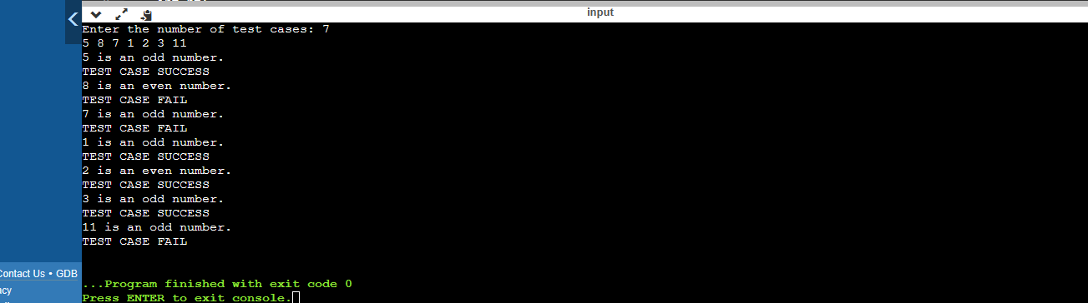

**TEST CASES:**

